Ezkylle Opiniano 1/13/2025
NW – 301 6BLOCKTECH
The objective of this assignment is to build a simple web application that:
- Connects to MetaMask wallet
- Shows which Ethereum network you're connected to (Mainnet, Sepolia, etc.)
- Displays the network's Chain ID
- Shows the icon based on the network

By the end of this task, you will:
- Set up a basic Web3.js project from scratch
- Understand project folder structure
- Connect a web page to MetaMask
- Read blockchain network information
- Handle user interactions with buttons

Pre-requisites:
- A web browser (Chrome, Firefox, or Brave)
- MetaMask extension installed

PART 1: Create Project Folder
Locate your folder on Drive E: (2185) and navigate to that folder.
Create a new folder: metamask-network-checker
Inside the new folder, open VS Code using code . command.
The objective of this assignment is to build a simple web application that:
- Connects to MetaMask wallet
- Shows which Ethereum network you're connected to (Mainnet, Sepolia, etc.)
- Displays the network's Chain ID
- Shows the icon based on the network

By the end of this task, you will:
- Set up a basic Web3.js project from scratch
- Understand project folder structure
- Connect a web page to MetaMask
- Read blockchain network information
- Handle user interactions with buttons

Pre-requisites:
- A web browser (Chrome, Firefox, or Brave)
- MetaMask extension installed

PART 1: Create Project Folder
Locate your folder on Drive E: (2185) and navigate to that folder.
Create a new folder: metamask-network-checker
Inside the new folder, open VS Code using code . command.
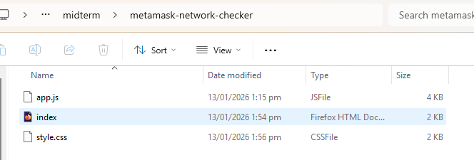

PART 2: Create HTML and JS files
Create an HTML file with the filename: index.html
Type the HTML code below:
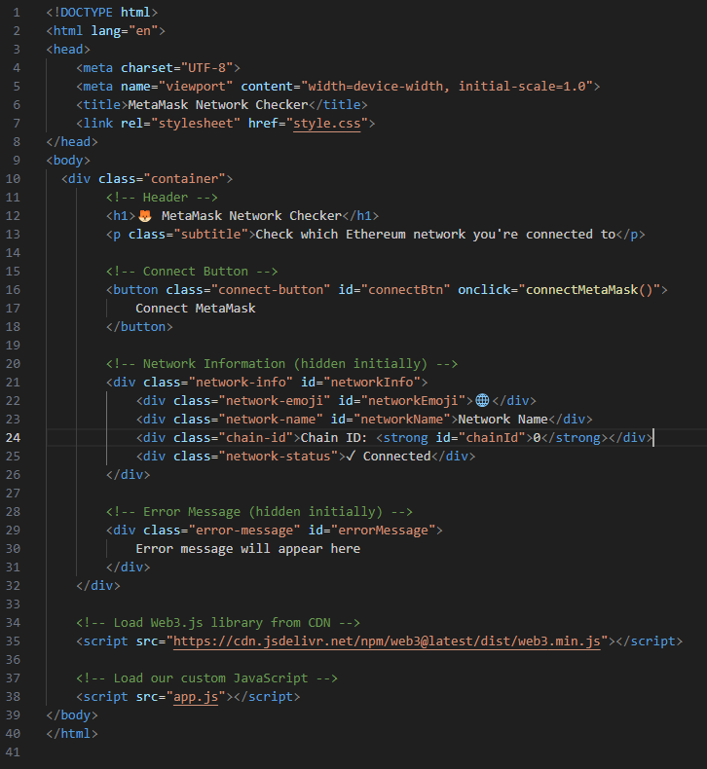

PART 3: Create the JS file.
Create a javascript file and save it as app.js
Type the code below:
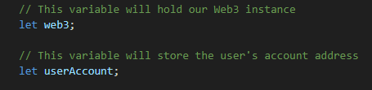
Function 1: Connect to Metamask
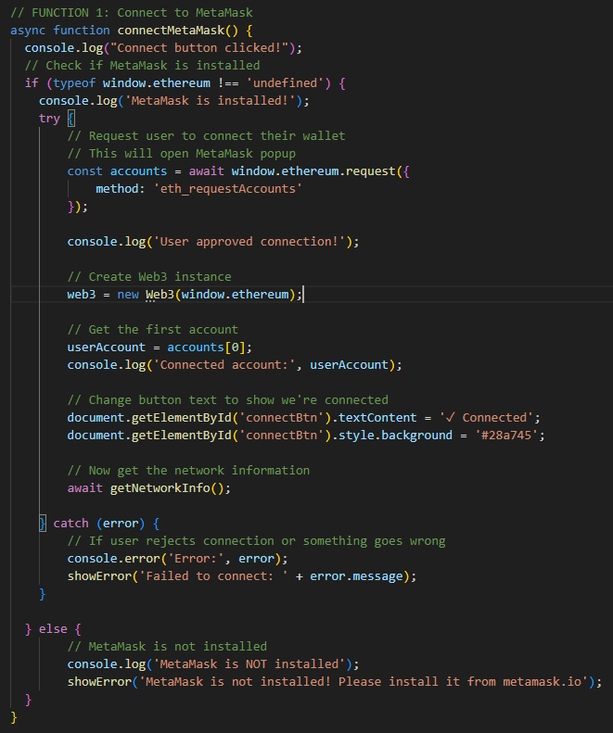

Function 2: Get Network Information
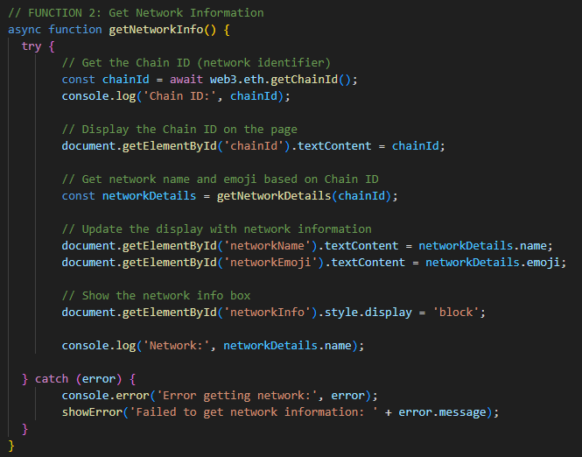
Function 3: Get Network Details by Chain ID
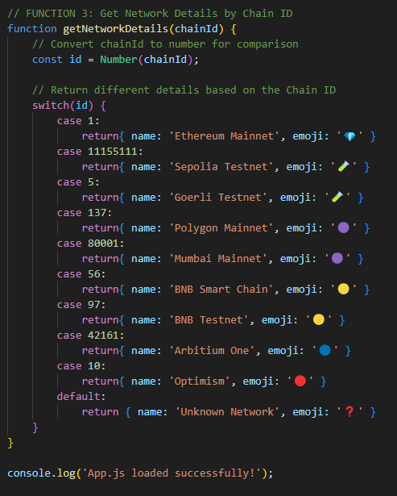

Format the interface and submit screenshots of the output. Sending the
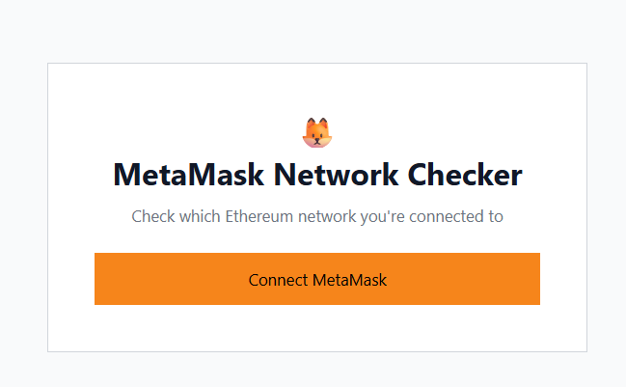
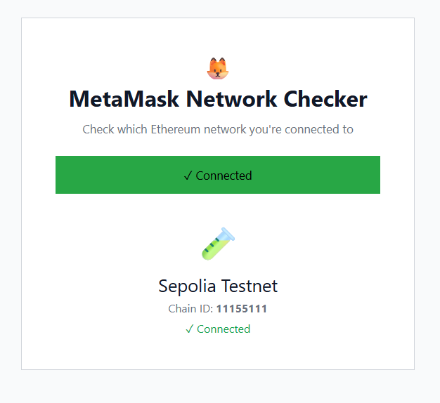
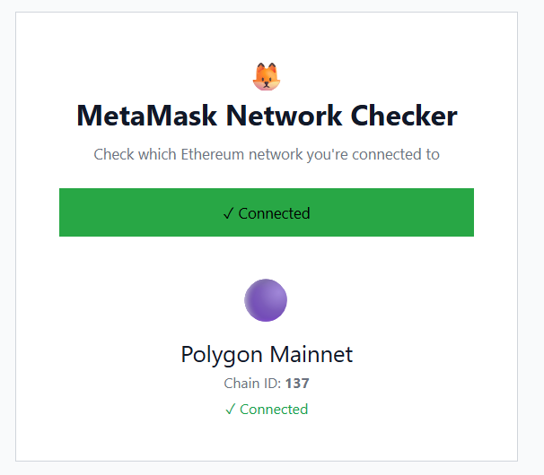

Account 2:
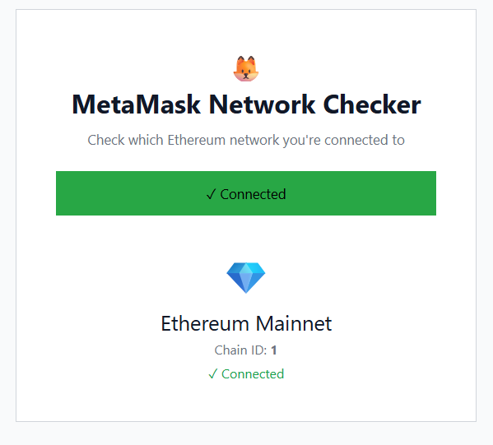

Reflection:
The integration of MetaMask with a basic web interface serves as a practical project to begin with decentralized application (dApp) development. The application is created using HTML and CSS and presents a clean and friendly interface that allows users to connect their wallets and verify network information easily. The page design along with the different types of visual feedback like emojis, status messages, and color changes not only enhance the user-friendliness of the application but also aid the beginners in understanding the blockchain concepts better by making them less imposing.

The JavaScript part of the project showcases the significance of async programming and proper error handling in the case of external wallets like MetaMask. By relying on Web3.js, the app astutely gets the person’s account and determines the Ethereum network that is connected by its Chain ID. The getNetworkDetails function effectively demonstrates that conditional logic can transform the jargons into easy-to-understand information, thus supporting the idea of abstraction in software development. In conclusion, this code shows a solid basic knowledge of front-end development, interaction with blockchain and user experience design, and at the same time, it points to clear feedback and smooth handling of possible errors as essential characteristics of the real-world decentralized applications.

